Public comments made/10/24 regarding the proposed.
NXT’s APPLICATION FOR RAIL YARD AND REFINERY
My name is Kevin Andrews I live at 80366 Quincy Mayger Rd in Clatskanie Oregon. I own 20 acres of designated forest land and I can see the proposed facility from my property.
I have asked many questions and voiced my concerns over the last couple years, most of which have yet to be answered or addressed. I want to be courteous to the format and time of everyone here so after making a couple points, I will submit my complete list in a written statement.
Often it feels as if these exercises are just to check a box, and then the questions and concerns of local community members are dismissed. If I was a smart guy I would follow the money, and those who stand to profit from projects like this are for them, while the concerns of residents – who are often left to deal with negative consequences – are dismissed.
I have worked in facilities like this in approximately 30 states in our country. Without exception, the communities surrounding become shitholes, smelly, dirty, polluted and run down. There is a reason these facilities are placed in industrial areas, not agriculture farmlands or wooded regions. No offense but look at the industrial area of Longview and tell me it isn’t so.
I respectfully request, that the Commission deny the NXT conditional use application for the portion of the rail yard that goes through agricultural land. The rail yard is not a branch line. LUBA has already concluded in 2022 that the rail facility that the county approved is not a branch line under OAR 660-012-0065(3)(j).
In addition, the area of the proposed rail yard sits behind dikes that are not certified by The Army Corps of Engineers. The BDIC has informed the Port, repeatedly, that the dikes are not certified by the Army Corp.
Also, the commission should find that NXT fails to meet CCZO 1562.3 which says that no roads shall be allowed in the buffer area. The application does not provide for a 10-foot buffer between the access road and the land to the north.
Thank you for allowing us time to speak and I will submit the remaining of my concerns and questions in written format to the Columbia County Land Development Services.

Below are other concerns which I have made publicly, as well as in written form, that have yet to be addressed:
1. Mr. Christopher Efird is fully involved in this project. His record of successfully completing even a smaller project is not exactly stellar. He was involved with a failed project that resulted in the project defaulting on all its obligations, financial, environmental, and moral and this resulted in some of his partners arrested. The project name was Transmessis Columbia Plateau in Odessa, Washington. The project site was such that it became a superfund cleanup site. Mr. Efird denied this allegation at a public meeting in Clatskanie, Oregon, where he lied to the City Council and a room full of Clatskanie citizens (my wife and I were there), as well as other citizens who live and work in the Clatskanie area of Columbia County. Not a good example of integrity. One of my concerns is that my neighborhood, (I can see this site from my house) could, potentially, become another environmental hazard disaster, damaging generations of fish and wildlife, which we who live here try to steward to the best of our abilities.
2. The mitigation that is going to have to be done by removing excellent farmland soil away and become a permanent wetland and can never be reclaimed for agriculture again, which today we should be trying to protect agriculture and not consign it over to the technocrats that are currently responsible for our freedoms being eroded, (but that is another topic for another day).
3. I have been recently made aware of this site being on the Lewis and Clark trail which would make it significant for historical reasons and as such, should be protected.
4. I am very concerned about the damage to the dikes/levees that will occur with the abundance of construction traffic and cannot find any mention of the requirement for the project to maintain and upkeep these very fragile systems.
5. Biodiesel processors generate substantial quantities of waste product, (about one gallon of waste product containing glycerol for every five gallons of biodiesel produced). Most processors also use water for fuel purification and may generate as much as three gallons of wastewater for each gallon of fuel produced. Both glycerol and wastewater require handling and disposal consideration. My concern here is; where and how will all this wastewater going to be processed and disposed?

These questions and concerns were voiced both in writing and orally regarding the DEQ Permit in April of 2022. To my knowledge, they still have not been addressed:

Proposed Renewable Diesel “NEXT” at Port Westward
I am writing this and submitting into the record for public comments. The reason I am writing is that the DEQ permit as proposed has some significant areas of concern and/or questions to be answered.
Section 8.0
I want to know how the NEXT proposes to loadout the Jet Fuel and Naphtha it will be producing at the Port Westward facility? This was not addressed in the proposed permit.
Section 10.1
I want to know how the surrounding community will be notified should excess emissions that could endanger public health be emitted?
Section 13.4
Masking of emissions: The permittee must not cause or permit the installation of any device or use any means designed to mask the emissions of an air contaminant that causes or is likely to cause detriment to health, safety, or welfare of any person. I want to use this language the next time Dr Fraud Chee wants to mask up civilization to further his agenda with the reptilian overlords that live under the ice in Antarctica. 😊
Section 22 VOC
According to Cleaner Air Oregon Table 3-2 and 3-12 they set a Flair stack height at between 350-418’ tall. This is based upon VOC emission factors. When looking at NEXTs permit application, the “potential to emit table” under the section regarding Flare startup/ Flare Shut down instead of giving a value it says CBI. I want to know how DEQ arrived at the overall number of VOCs emitted per year if the data is not included in the permit application. Startup and shutdowns can and do cause spikes in VOC emissions and these can be significant depending on frequency and adding in an occasional flare incident. I think these merits further clarification.
The flair stack height is also a factor and since Oregon Cleaner Air table 3-2 and 3-12 give two different heights this needs to be clarified to properly give the VOC numbers. I want to know what the flare stack height is going to be that contributes to the VOC 70 tons number quoted in the DEQ proposed permit.
DEQ arrived at 70 tons of VOCs in the permit as proposed. What is conspicuously absent from the data is the rail/truck and marine contributions. Just daily traffic in and out of the facility by full time employees will be approximately an additional 250-300 cars and trucks. This does not factor in a 400-car rail spur, who knows how many Semi-trucks hauling diesel from the facility and the major increase in ship traffic. The ships that travail the Columbia River are a constant source of emissions. I want to know why none of this vital and necessary component to NEXTs operation was not factored into the 70 Tons of VOCs in the DEQ permit?
22.c
The permittee was required to perform an Ozone Precursor Distance Calculation and they determined the distance to be 52.1 km. which is just under 8 km. from Portland Vancouver Maintenance Area. I find this very suspicious and would like to verify they took into consideration the prevailing winds. Someone more qualified than I should verify this was done properly and if not DEQ should at least release the report to the public for closer scrutiny. It is because, in part, of this Ozone Precursor Distance Calculation that emission offsets are not required.
This was submitted by my wife for the same DEQ hearing:
Dear Oregon DEQ:
I urge you to reject the proposed air permit for the NEXT refinery proposal at Port Westward, Oregon. The proposed air pollution permit will allow harmful pollution to impact nearby residences, farms, and a Buddhist monastery. Further, the draft permit offers inadequate information to ensure that the refinery would meet state and federal air quality standards.
- NEXT’s proposed refinery and its pollution would have a major impact on the Port Westward community, adding to other sources of air and pollution already allowed by DEQ.
- DEQ proposes inadequate constraints on the refinery’s air pollutants, such as volatile organic compounds (VOCs) and hydrogen sulfide. DEQ’s proposed limits for toxic and hazardous pollution fail to protect nearby residents, family farms, and businesses. DEQ should establish enforceable limits on volatile organic compounds and include more robust, verifiable monitoring requirements. Combined with other polluters in the area, NEXT’s proposal will have a major impact on the community.
- DEQ fails to regulate emissions that will occur at the 400-car rail yard and marine vessel loading and unloading activities. NEXT should be responsible for the air pollution from ships and trains serving the diesel refinery at Port Westward.
- DEQ does not adequately address the potential for the proposed refinery to emit noxious odors. The refinery proposes to convert animal fats, waste oil, or purpose-grown feedstocks into renewable diesel, a process with clear potential to impact people living nearby.
- DEQ cannot afford to take NEXT at its word when it comes to pollution. Key officials in NEXT were involved in a failed biofuels project in Odessa, WA called Transmessis Columbia Plateau with the company when Transmessis went belly-up after a crash in biofuels price.
- Short of rejecting the permit, DEQ should withdraw the proposed draft air permit for NEXT and provide additional information that demonstrates why the project will be a minor source of emissions when the potential clearly exists for the NEXT refinery to be a major source of air pollution.
Because of these impacts and unresolved issues, DEQ should reject the air permit proposed for NEXT. Oregonians rely on DEQ to protect their air and water, and they cannot trust NEXT, a company whose backers have a dubious track record. Homes, farms, businesses, wildlife habitat, and a nearby monastery are all vulnerable to potential pollution from the NEXT refinery and rail yard, and DEQ’s current approach falls far short of offering the protection that the community deserves.
Dee Dee Lively Andrews
Lastly is a copy of my letter written to the Columbia County Commissioners in January of 2022 which of course was un-answered.
To whom it may concern,

My name is Kevin Andrews. I live at 80366 Quincy Mayger Rd. Clatskanie, Oregon 97016.

This letter is to express my concerns about the proposed NEXT Renewable Fuels Project.

I have met with members of the Beaver Creek Drainage District regarding this proposed project, attended public meetings, and personally communicated with members of the NEXT project regarding my concerns. Those concerns and reservations remain, however, especially since this proposed project is, quite literally, in my back yard.

I own 20 acres of Designated Forestland, that just happens to be the land where I intend to retire and enjoy the pleasures of being out in nature. My forested parcel of land overlooks the Columbia River and Crims Island approximately 4 miles east of the proposed NEXT Renewable Fuels site. During the winter I can see the buildings at Port Westward through the trees.

In the interest of full disclosure, I work as a Quality Control Manager and my expertise is in the petro/biochemical field. I have traveled the country working in refineries and chemical facilities for Exxon, Chevron, Texas Petroleum, Tesoro, BASF, Intel and others. I worked as Chief Inspector for the metering station project at the Port Westward facility that connected the Compressor station we built and piped in the Mist Mountain range that sits between Vernonia and Clatskanie. I explain this because I am familiar with Port Westward and I have an intimate knowledge of facilities like this and understand the impacts, both positive and negative, this proposed project could have – like I said, “in my back yard.”

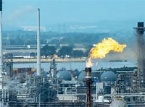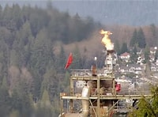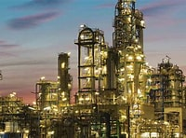

The project proposed by NEXT will alter the character of the surrounding area in a manner that substantially conflicts with the lifestyle and, frankly, the daily existence of the people in this neighborhood. This is not an industrial area – the Columbia River facilitates industry – but not in an area where people live – and live off of the land. For instance, just down the road from my property, at Batwater Station, is a recently expanded 26-acre salmon habitat that also hosts waterfowl, turtles, and the endangered Columbia River White Tail Deer. Oh, yes - and bats!
The physical area of the proposed project is surrounded by some of the finest organic Blueberry and Organic Mint farms you will find in the whole country. Many Bald Eagles nest along the banks of the river, some within view of my house. There is mink, raccoons, (which are cute as heck but an extreme nuisance), a couple families of coyotes, (I wish they ate more raccoons), and the red legged frogs, that make this land their home. Local ranchers graze their cattle, and local farmers use this area for feed and grains in addition to growing crops for the market. Nearly 40 local farms will be affected by this project.

A diesel fuel refinery simply doesn’t fit in our rural, agricultural setting. (It would be like setting up a rock and roll band next door to a daycare facility.)

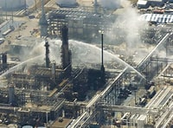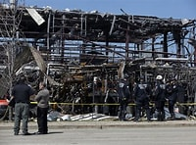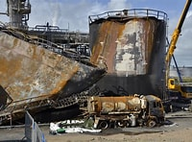

My concerns are valid, as are those of my concerned Columbia County neighbors – we must not be ignored! If approved, this project will impact and change our neighborhoods permanently and, in my opinion, to the detriment of all living things that make this area their home.

There are currently a few trains that travel through our neighborhoods and properties along the Columbia River. NEXT CEO, Mr. Christopher Efird, has stated that trains would only be used “as needed.” I know for a fact that the “as needed” status does not mean every now and then.

I also know that the most efficient way to move fuel products is via pipelines. Since there is currently no pipeline distribution system in place (for this project) the most efficient way of moving the product to distribution facilities around the country is by rail, which means we have the potential of having hundreds of slow-moving rail cars daily and/or weekly if and when the proposed facility hits the production numbers, they are projecting.

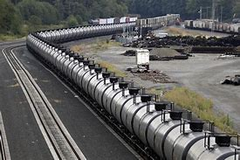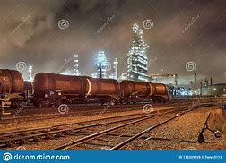
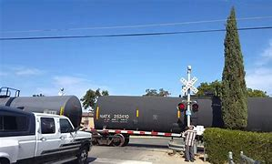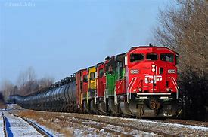

This could mean delays at road crossings which could cause issues with emergency personnel responding to calls; it could mean costly delays of moving crops to market. The few trains that do travel this track already cause a few local residents’ issues with ingress and egress to their own property from the public road. Then there is the noise pollution that interrupts the tranquility of our neighborhoods. A major concern is the characteristics of the proposed refinery site, (successful agricultural operations and sensitive wetland areas), are not suitable for a rail line used to transport fuels on an industrial scale. I believe the rail line activity will be in direct conflict with the surrounding agriculture and rural setting we currently have.

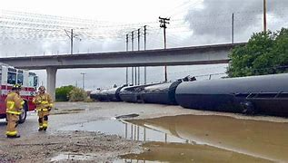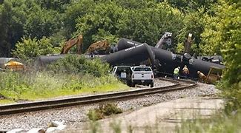

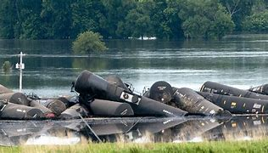

The county road that provides access to – and through – this neighborhood is not capable of handling the daily traffic this project will necessitate, especially in the construction phase. The NEXT website propounds that “over 5,000 jobs will be added during the construction phase” of this project. That is two and a half times the population of Clatskanie! (The job opportunities will obviously benefit more out-of-towners than locals.) Beaver Falls Road, Alston Mayger Road, and Quincy Mayger Road are winding country roads that get beat up every year just by the local traffic and winter weather conditions – and the maintenance for these roads always remains a “job half done.” Just last month we had over 7 inches of snow in one night, which, after being plowed (the parts of the road that get plowed, that is) left many areas where the asphalt was covered with ice for days simply because it is old, and the asphalt surface is not level enough to plow completely.

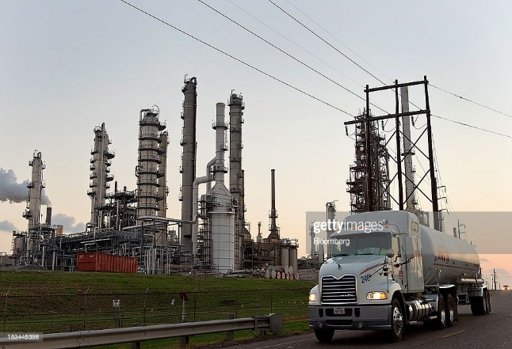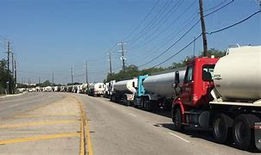

At a meeting with the Clatskanie City Council, Mr. Efird stated that there would be some truck traffic. I worked at a small refinery in Billings, Montana that received upwards of 15-20 full sized semi-trucks daily to transport product to market. It will be impossible to ship all final product to distribution facilities in the heartland of our country via ship because there are only 16 states that have Oil Ports. I would ask that you look at Wilcox and Flegel, in Longview, as an example of a distribution facility. There are several dozen tanker trucks coming in and out of the yard in Longview daily. The St Helens location has dozens a day, as well. Our quaint little agricultural neighborhood would be disrupted with all this extra traffic from heavy trucks on a small two-lane road that was not designed for heavy tractor-trailer traffic.

This proposed refinery is not water-dependent, although that would solve the train and truck issues. Many similar refineries throughout the US don’t use water-based transportation and/or distribution systems at all. Just because the applicant desires to ship refined fuels by water to reduce their carbon intensity score doesn’t make the facility water dependent. When a plant’s production is enough to ship 50,000 barrels of final product a day, they will, more than likely, be using tanker ship, rail, and truck.

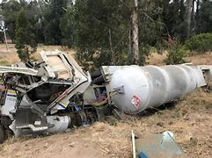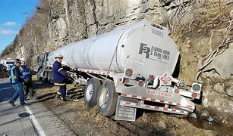
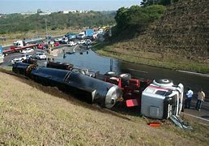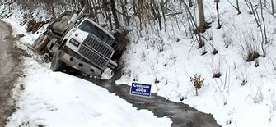

The proposed refinery does not compliment the character and development of the surrounding rural area in any way. I could live anywhere in this country, but I chose this place because it is perfectly situated just far enough away from the big cities to be out of the sprawling asphalt jungle, yet near enough to support the occasional shopping and/or entertainment outings available only in a larger population area.

A specific concern which merits serious consideration is that Mr. Chris Efird, Founder, CEO, and Chairman of the Board of NEXT Renewables, was involved with a biodiesel project in Odessa Washington, Transmessis Columbia Plateau, LLC. Transmessis was shut down abruptly and all employees were terminated just 7 months after opening. The site was abandoned by Transmessis, resulting in the EPA designating it as an Emergency Response Site, where they performed an inventory and assessment of the chemicals that were left behind and improperly stored.

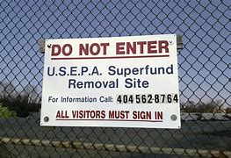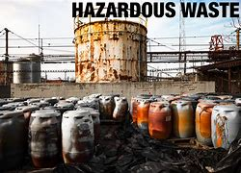

Not only was the site abandoned but they left with over 2 million dollars owing vendors, employees, and state taxes, (which were finally paid only after being taken to court). The clean-up of mishandled chemicals took courts and litigation to resolve. The failed project in Odessa, Washington is dwarfed by the proposed Port Westward facility by a hundred-fold. Just think of the potential damage a project like this could pose, only a few hundred yards from the waters of the Columbia River that supports both commercial and private traffic not to mention our protected and diminishing Salmon runs.

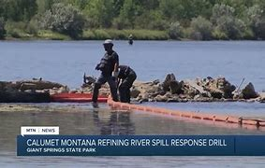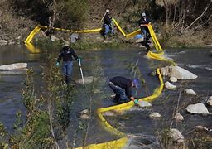

Another point of contention is the wetland mitigation required for the proposed refinery. This agricultural farmland that will be re-purposed and converted to a wetland will forever be lost to our local community for grazing, for agriculture, and for recreation. I happen to believe that we should be trying to preserve resources such as this, not deplete them, especially considering the current climate issues. It makes no sense to disturb acres of agricultural land to produce a product that supposedly will cause the climate to be better for… agriculture?

A question yet to be answered is why this project was not proposed for an already established industrial community such as the Longview/Kalama, Washington area? Oh, wait - perhaps it was! Perhaps the Port of Longview Commissioners did their homework and chose safety and honesty over the possibility of lots of cash in the Port coffers. Please see the following articles that are pertinent to this project.

https://olywip.org/can-longview-oil-refinery-pass-due-diligence-an-examination-of-the-companies-and-individuals-behind-the-dubious-proposal/

https://www.columbiariverkeeper.org/news/2016/2/longview-oil-refinery-propane-terminal-are-dirty-dangerous

The Proposed Longview Refinery: Understanding the Basics - Sightline Institute

That could explain why NEXT might try to steamroll the citizens of this little community, who seem to be in awe of the big ideas and the big promise of prosperity – without the little details (truth) of the end cost to our community.

Clatskanie Oregon has a current population of approximately 1,850 residents as of 2018. The Protect Oregon Farms group has collected nearly 600 signatures of local community members. Over 100 agricultural business and community organizations have said NO to NEXT. This represents nearly half of the community. If the County was listening to their constituents, they would realize that half of the community is against this project in this location. The County should pause and reflect upon the wishes of the community they represent.

Most of us realize business is essential to our survival. Any fair-minded person would agree that Clatskanie would receive immense financial benefit if this project is approved, completed and operational. It will be a boom for businesses, employment, and necessary revenue - for a relatively short period of time. Mr. Efird has been open in his disclosure that this plant will be in operation for a mere 25 years. Possibly less than that, depending on how long it takes to bring the plant to full production - including propane and jet fuel.

The issue we, the people have, is that this proposed project, very simply, should not be at this location. Quincy is not the place to sacrifice for any refinery, least of all one that will become an empty shell in such a short period of time. Most of us agree that our ecologically sensitive, rich agricultural, and quiet neighborhoods (except for the occasional hunter’s gunshots) is most definitely NOT the place for NEXT Renewable Fuels. I am not opposed to progress even in my own back yard, but “progress” should not come at a cost for future generations.

Respectfully,
Kevin Andrews

In Summary:

Please consider all these serious concerns when deciding on a permit application and at the very least postpone it so the stakeholders can answer this community's questions in a public and transparent way. Then, maybe, we can get on board the NXT train :).
Sincerely,
Kevin Andrews

